Levenshulme Old Library CIO (LOLCIO) Safeguarding Policy

To be read in conjunction with the LOLCIO Safeguarding Statement

Levenshulme Old Library CIO (LOLCIO) is committed to ensuring that young people and vulnerable adults who use our services, work with us, and for us, are not abused and that our working practices minimise the risk of such abuse. All Trustees, Staff, and Volunteers of LOLCIO have a duty to identify abuse and report it.

Due to the nature of our organisation as the venue of and an enabler of activities within Levenshulme Old Library, LOLCIO does not directly work with or provide services to vulnerable people and would most likely do so through intermediaries, such as those hiring Levenshulme Old Library for activities they run or partners collaborating on a project. Nevertheless, we take our duties to provide a safe building seriously.

Please refer to the 2025 addendum on children’s safeguarding for more information.

Definition of Vulnerable People
Vulnerable people may be unable to take care of themselves and unable to protect themselves from harm or exploitation by other people. We define vulnerable people as primarily either:

- Young people under the age of 18.
- Vulnerable adults who are over 18 years of age and are getting or may need help and services to live in the community.

The aim of this policy is to establish best practice guidelines to safeguard vulnerable people at risk of abuse and neglect. This policy is our commitment to the following principles:

- Everyone using our services, working with us, and for us are safe.
- Everyone has the right to live their life free from violence, fear, and abuse.
- Everyone has the right to be protected from harm and exploitation.
- Everyone has the right to self-determination, which may involve a degree of risk.

Types of Abuse
Abuse can include:

- Physical
- Financial
- Material
- Sexual
- Psychological
- Discriminatory
- Emotional abuse
- Neglect
- Cyberbullying
- Online exploitation

Abuse can take place in any setting, public or private, and can be perpetrated by anyone.

Rights and Responsibilities
Responsibilities of all Trustees, Staff, and Volunteers of LOLCIO:

- To ensure all are aware of vulnerable peoples’ need for protection.
- To notify the appropriate agencies if abuse is identified or suspected.
- To support and where possible secure the safety of individuals and ensure that all referrals to services have full information in relation to identified risk and vulnerability.
- If necessary, to undergo checks through the Disclosure and Barring Service (DBS) for all Trustees, Staff, and Volunteers of LOLCIO that have access to or work with Vulnerable People.
- To be familiar with the vulnerable people safeguarding policy.
- To take appropriate action in line with the policy of LOLCIO.

Support for Those Who Report Abuse:

All those making a complaint or allegation or expressing concern, whether they are Trustees, Staff, and Volunteers of LOLCIO or service users or members of the general public should be reassured that:
- They will be taken seriously.
- Their comments will usually be treated confidentially, but their concerns may be shared with the appropriate authorities if they or others are at significant risk.
- LOLCIO has a named Safeguarding Lead who will be responsible for investigating any alleged abuse and taking any appropriate action.

Support for Vulnerable Individuals

The vulnerable person has the right:

- To be made aware of this policy.
- To have alleged incidents recognised and taken seriously.
- To receive fair and respectful treatment throughout.
- To be involved in any process as appropriate.
- To receive information about the outcome.

Digital Safeguarding
With the increasing use of digital platforms, LOLCIO is committed to ensuring the safety of vulnerable individuals online. This might include:

- Monitoring online interactions to prevent cyberbullying and online exploitation.
- Providing guidance on safe internet use to users where appropriate.
- Reporting any online abuse to the appropriate authorities promptly.

Training

- Regular safeguarding training will be provided for Trustees, Staff, and Volunteers where required, including updates on the latest best practices.
- Specialised training will be offered for those directly involved with vulnerable groups.
- Public awareness of the safeguarding policy will be promoted via LOLCIO’s website.

Safeguarding Lead:

Name: Richard Hirst
Address: Levenshulme Old Library, Manchester M19 3QE
Telephone: 07445970758
Position: General Manager

Review
We are also committed to reviewing our policy and good practice regularly, and this will normally be annually. This policy will be reviewed at intervals of one year to ensure it remains up to date and compliant with the law.

Responsibilities:

- Trustees: Share overall and final responsibility for equal opportunities.
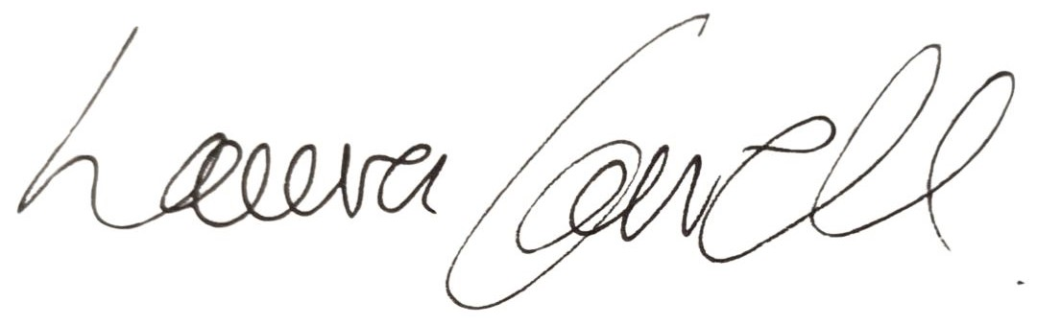
- Named Project Lead: Has responsibility for ensuring this policy is put into practice on location during projects and events.

Signed: _____________

Laura Carroll, Chair, Levenshulme Old Library CIO

Date: 18.02.25
Next Review Date: 18.02.26
Safeguarding Policy Addendum: Children’s Safeguarding

1. Definitions

Child: For the purposes of this policy, a child is defined as any individual under the age of 18.
Vulnerable Adult: A vulnerable adult is someone aged 18 or over who may be unable to protect themselves from harm or exploitation due to factors such as physical or mental health issues, disability, or age-related frailty.

2. Responsibility to Protect

It is our responsibility to ensure the safety and well-being of children and vulnerable adults. This duty arises from the understanding that these groups may be more susceptible to abuse and exploitation due to their developmental stage, dependency, or individual circumstances. Safeguarding them is crucial to providing a safe and supportive environment.

3. Distribution of Policy

This policy is distributed to all Trustees, Staff, and Volunteers of LOLCIO. It is also accessible to parents, carers, and other stakeholders via our website and printed copies upon request.

4. Definitions of Abuse

Abuse: Abuse encompasses any action or inaction that causes harm or distress. It can be physical, emotional, sexual, or neglectful.
For Children: Abuse may include physical harm, emotional abuse, sexual exploitation, or neglect. Signs can include unexplained injuries, changes in behavior, or fearfulness around certain individuals.
For Vulnerable Adults: Abuse may involve physical harm, financial exploitation, neglect, or psychological abuse. Indicators can include unexplained injuries, sudden changes in financial situation, or withdrawal from social interactions.

5. Safeguarding Lead

Name: Richard Hirst
Position: General Manager
Contact Details: richard@levenshulmeoldlibrary.org.uk

6. Local Safeguarding Board

Name: Manchester Safeguarding Partnership

7. Procedure for Reporting Concerns

Any safeguarding concerns should be reported immediately to the Safeguarding Lead. If the concern involves the Safeguarding Lead, it should be reported to the Chair or another designated contact within the organisation. Reports should be documented and, if necessary, referred to the local safeguarding board for further action.

8. Recruitment and Training

All Trustees, Staff, and Volunteers on relevant projects must undergo:

DBS Checks: Disclosure and Barring Service checks for individuals working with children and vulnerable adults.
Safeguarding Training: Mandatory safeguarding training, including updates on best practices.

9. Policy Review

This policy will be reviewed annually to ensure it remains effective and up-to-date. Updates will be made as necessary to reflect changes in legislation or organisational practices.

Signed:

Laura Carroll, Chair, Levenshulme Old Library CIO

Date: 18.02.25
Next Review Date 08.02.26

